Test Case: tc002_SPX_Dev5_Crear_Requisicion_Spot_Con_FAD_Tipo_Cobro_CC
Step 1 - Enter username and password and click to button Enter : Credentials Entered
Image file-name: QC_Testing-tc002_SPX_Dev5_Crear_Requisicion_Spot_Con_FAD_Tipo_Cobro_CC-1790169913297

Step 2 - Select to UEN and Access to Spot Buy Requisitions : UEN Correctly selected and Correct access
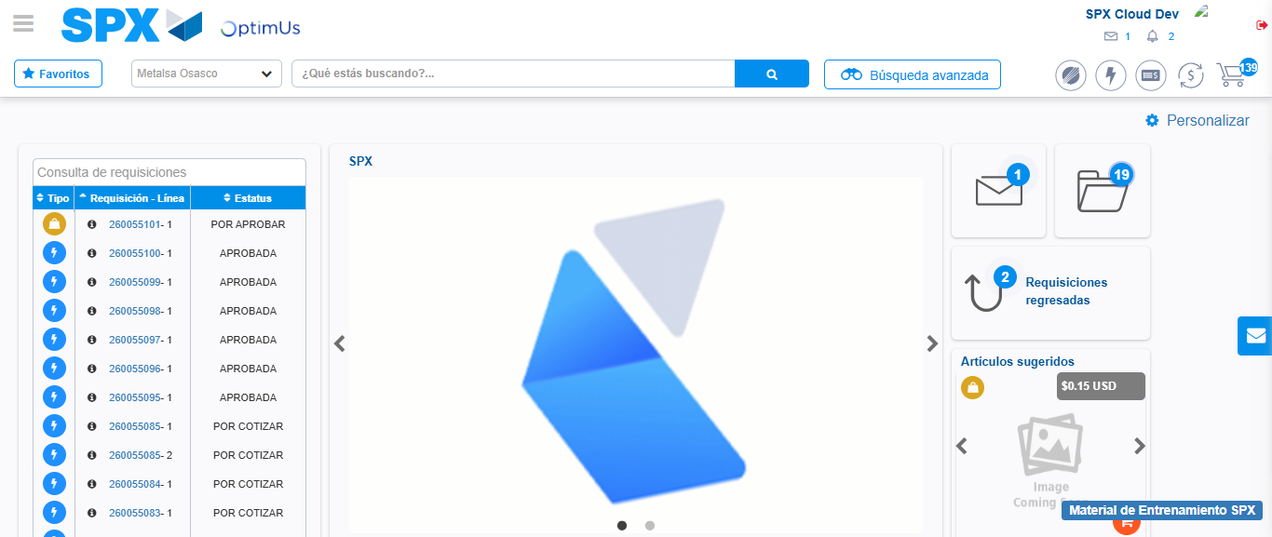Image file-name: QC_Testing-tc002_SPX_Dev5_Crear_Requisicion_Spot_Con_FAD_Tipo_Cobro_CC-1790169937291

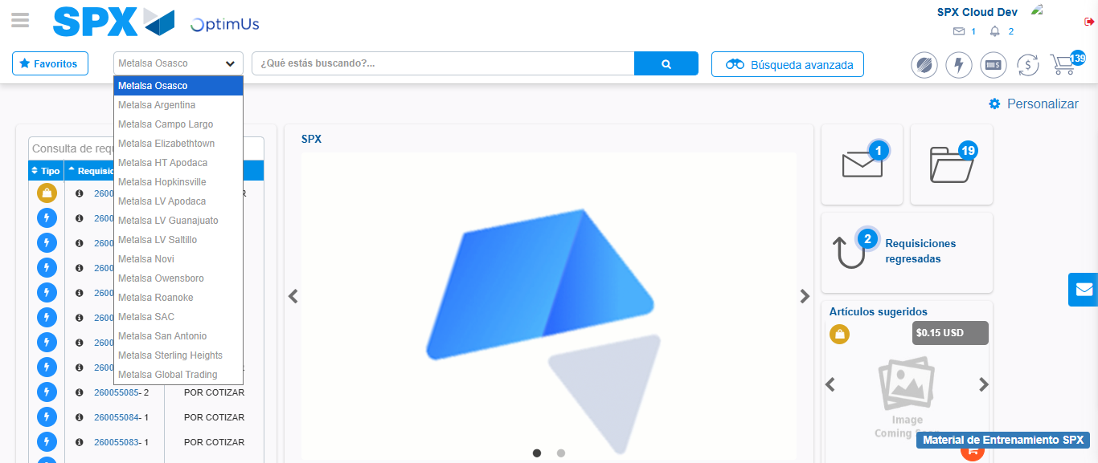Image file-name: QC_Testing-tc002_SPX_Dev5_Crear_Requisicion_Spot_Con_FAD_Tipo_Cobro_CC-1790169938011

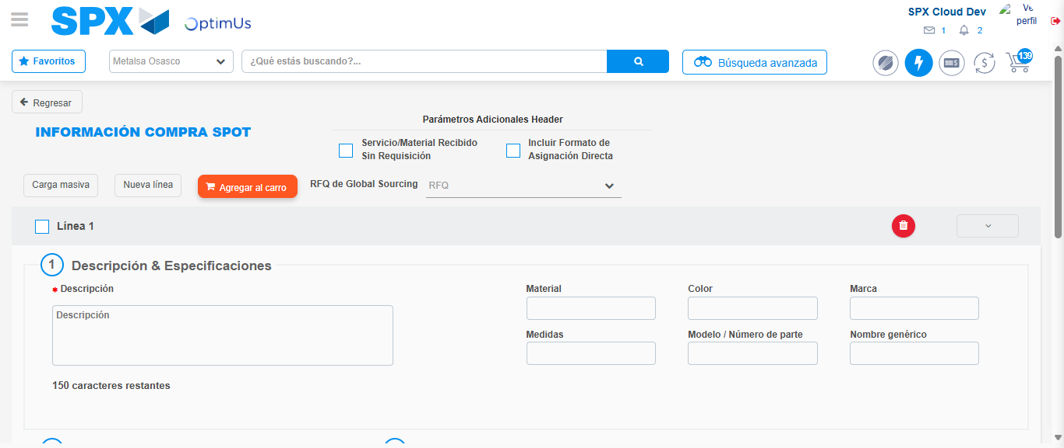Image file-name: QC_Testing-tc002_SPX_Dev5_Crear_Requisicion_Spot_Con_FAD_Tipo_Cobro_CC-1790169955380

Step 3 - Add FAD to Requisition: FAD Successfully Added
Image file-name: QC_Testing-tc002_SPX_Dev5_Crear_Requisicion_Spot_Con_FAD_Tipo_Cobro_CC-1790169955650

Image file-name: QC_Testing-tc002_SPX_Dev5_Crear_Requisicion_Spot_Con_FAD_Tipo_Cobro_CC-1790169955846

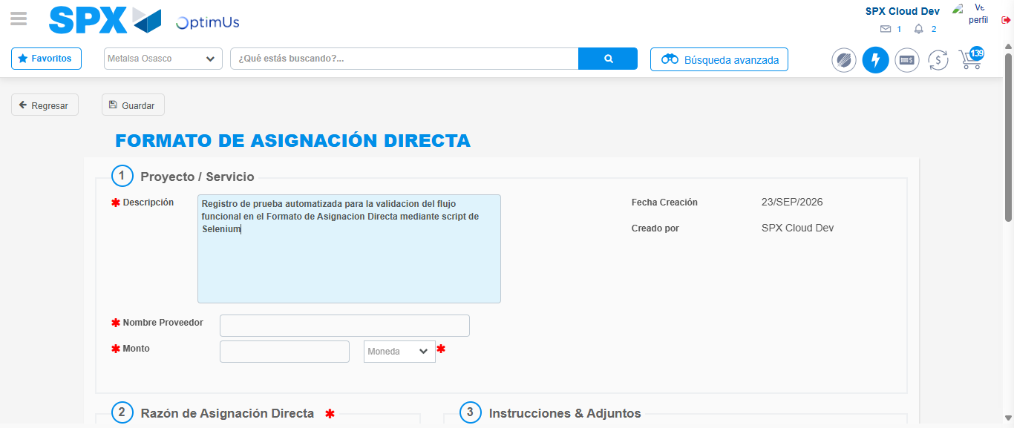Image file-name: QC_Testing-tc002_SPX_Dev5_Crear_Requisicion_Spot_Con_FAD_Tipo_Cobro_CC-1790169958718

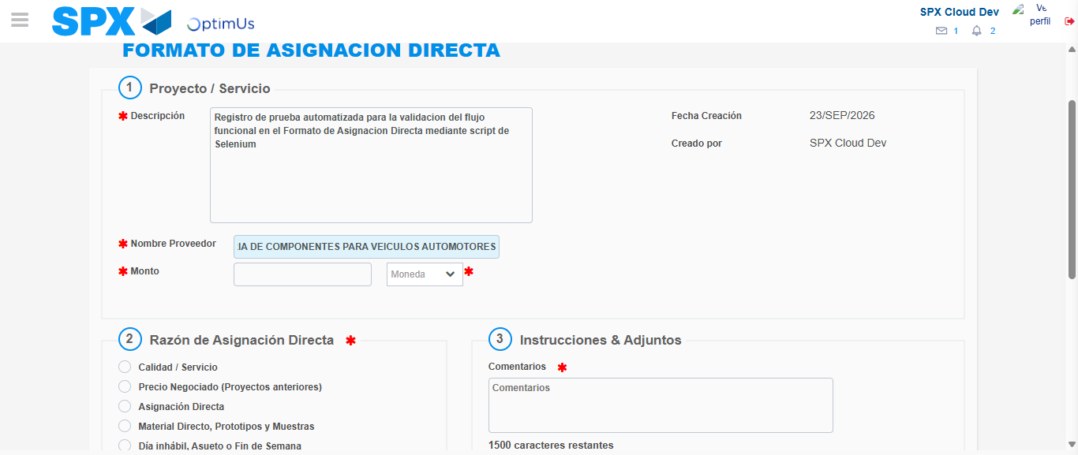Image file-name: QC_Testing-tc002_SPX_Dev5_Crear_Requisicion_Spot_Con_FAD_Tipo_Cobro_CC-1790169987576

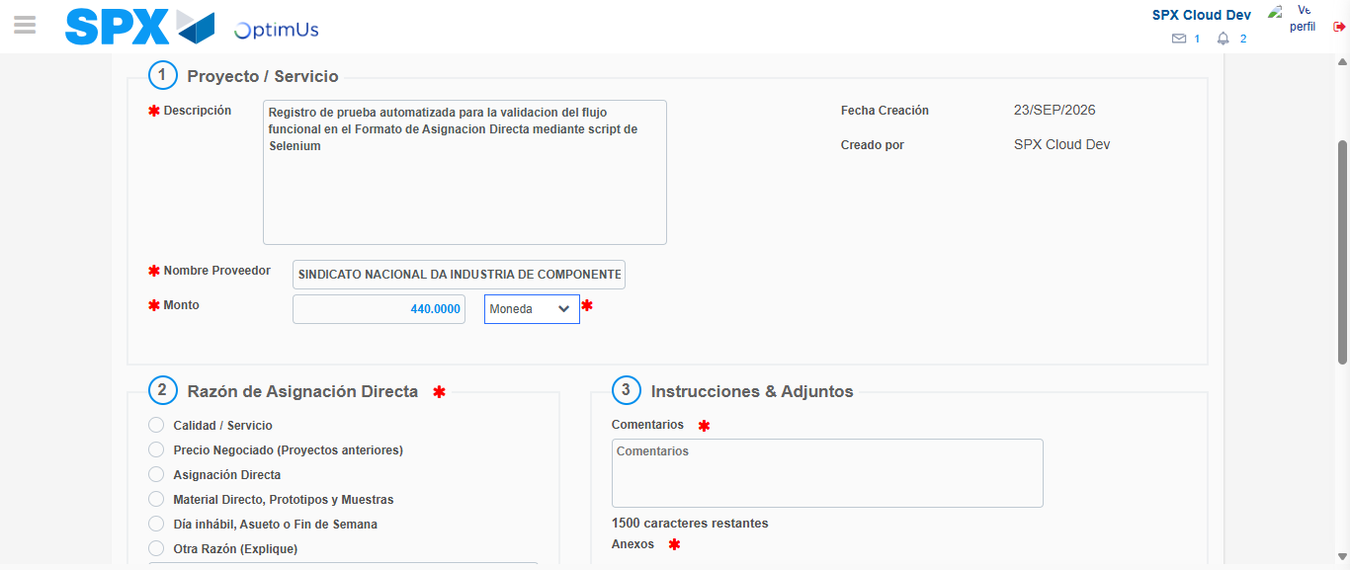Image file-name: QC_Testing-tc002_SPX_Dev5_Crear_Requisicion_Spot_Con_FAD_Tipo_Cobro_CC-1790169988060

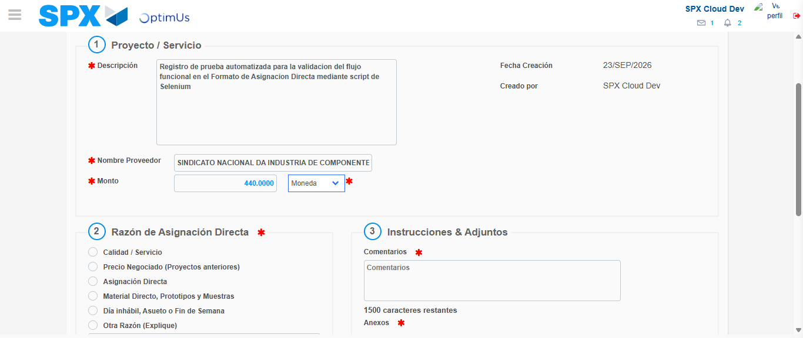Image file-name: QC_Testing-tc002_SPX_Dev5_Crear_Requisicion_Spot_Con_FAD_Tipo_Cobro_CC-1790169988314

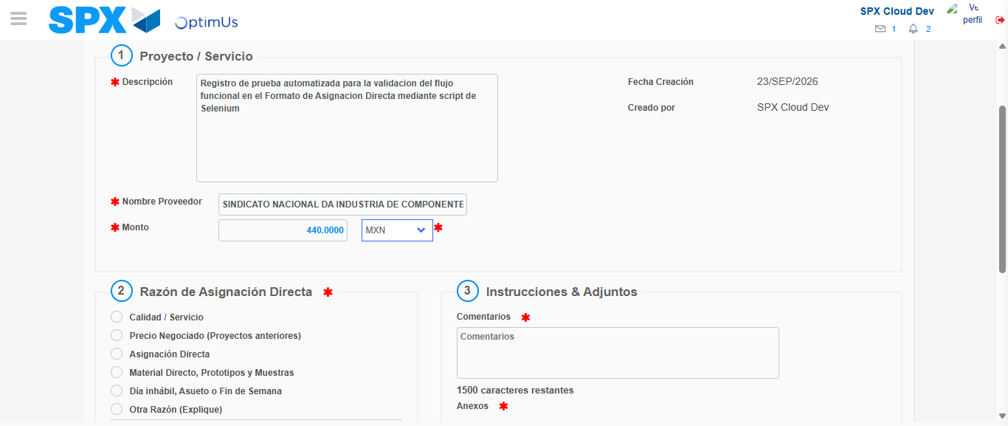Image file-name: QC_Testing-tc002_SPX_Dev5_Crear_Requisicion_Spot_Con_FAD_Tipo_Cobro_CC-1790169988880

Image file-name: QC_Testing-tc002_SPX_Dev5_Crear_Requisicion_Spot_Con_FAD_Tipo_Cobro_CC-1790169989090

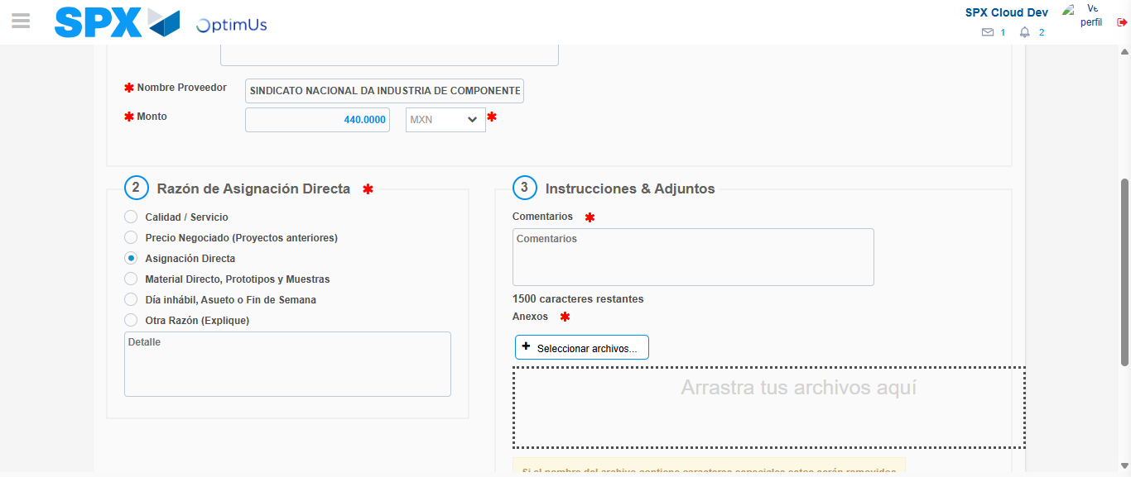Image file-name: QC_Testing-tc002_SPX_Dev5_Crear_Requisicion_Spot_Con_FAD_Tipo_Cobro_CC-1790169989972

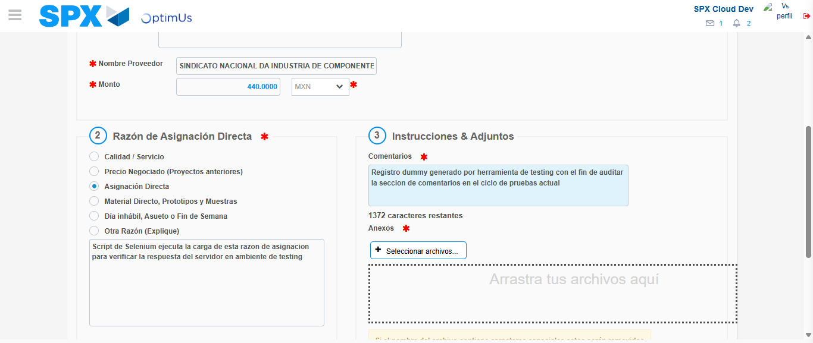Image file-name: QC_Testing-tc002_SPX_Dev5_Crear_Requisicion_Spot_Con_FAD_Tipo_Cobro_CC-1790170001097

Image file-name: QC_Testing-tc002_SPX_Dev5_Crear_Requisicion_Spot_Con_FAD_Tipo_Cobro_CC-1790170001916

Step 4 - Data Capture Spot Buy Requisition: Data captured correctly
Image file-name: QC_Testing-tc002_SPX_Dev5_Crear_Requisicion_Spot_Con_FAD_Tipo_Cobro_CC-1790169955650

Image file-name: QC_Testing-tc002_SPX_Dev5_Crear_Requisicion_Spot_Con_FAD_Tipo_Cobro_CC-1790169955846

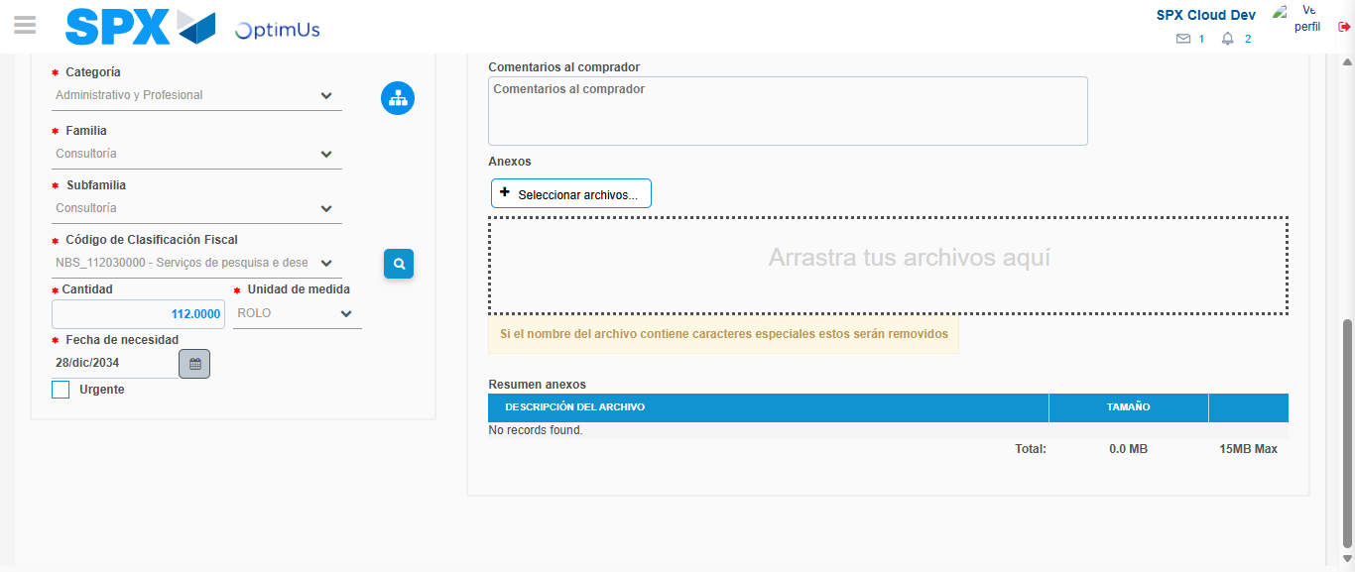Image file-name: QC_Testing-tc002_SPX_Dev5_Crear_Requisicion_Spot_Con_FAD_Tipo_Cobro_CC-1790170020871

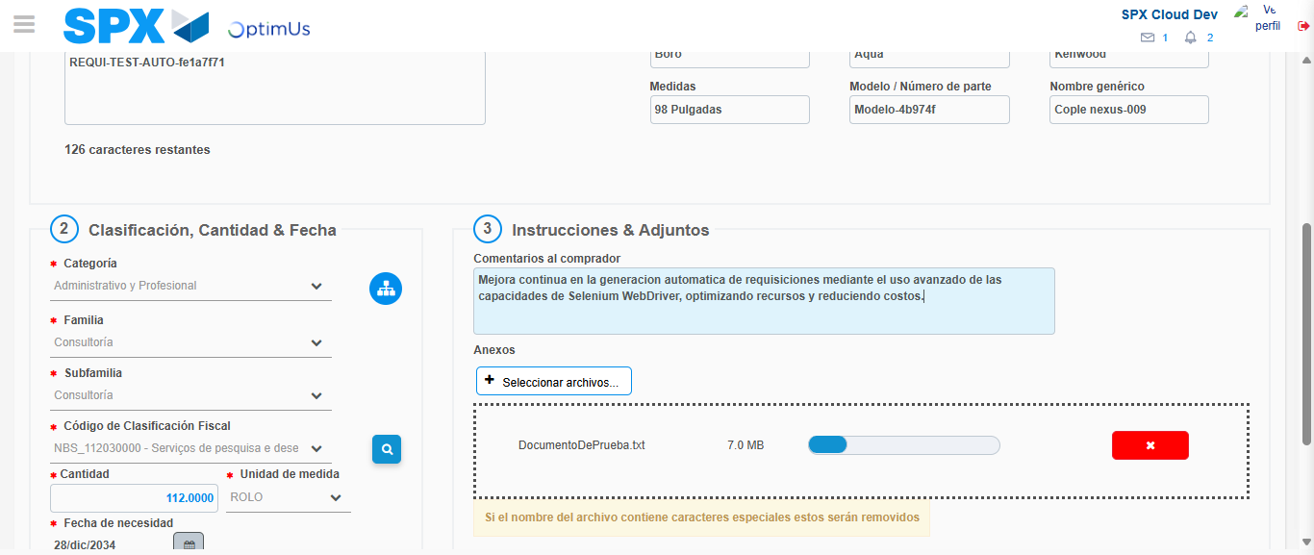Image file-name: QC_Testing-tc002_SPX_Dev5_Crear_Requisicion_Spot_Con_FAD_Tipo_Cobro_CC-1790170021750

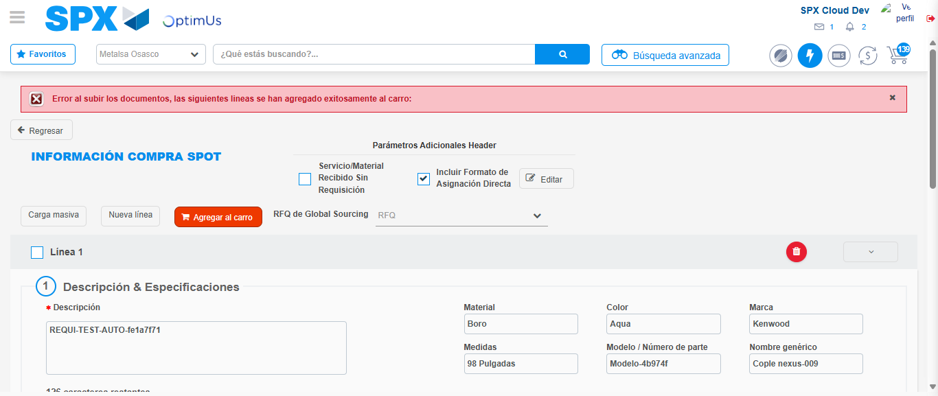Image file-name: QC_Testing-tc002_SPX_Dev5_Crear_Requisicion_Spot_Con_FAD_Tipo_Cobro_CC-1790170034627

Step 8 - Return to Main Page SPX : Return to Main Page SPX
Image file-name: QC_Testing-tc002_SPX_Dev5_Crear_Requisicion_Spot_Con_FAD_Tipo_Cobro_CC-1790169937291

Image file-name: QC_Testing-tc002_SPX_Dev5_Crear_Requisicion_Spot_Con_FAD_Tipo_Cobro_CC-1790169938011

Image file-name: QC_Testing-tc002_SPX_Dev5_Crear_Requisicion_Spot_Con_FAD_Tipo_Cobro_CC-1790169955380

Image file-name: QC_Testing-tc002_SPX_Dev5_Crear_Requisicion_Spot_Con_FAD_Tipo_Cobro_CC-1790170036921

Image file-name: QC_Testing-tc002_SPX_Dev5_Crear_Requisicion_Spot_Con_FAD_Tipo_Cobro_CC-1790170037129

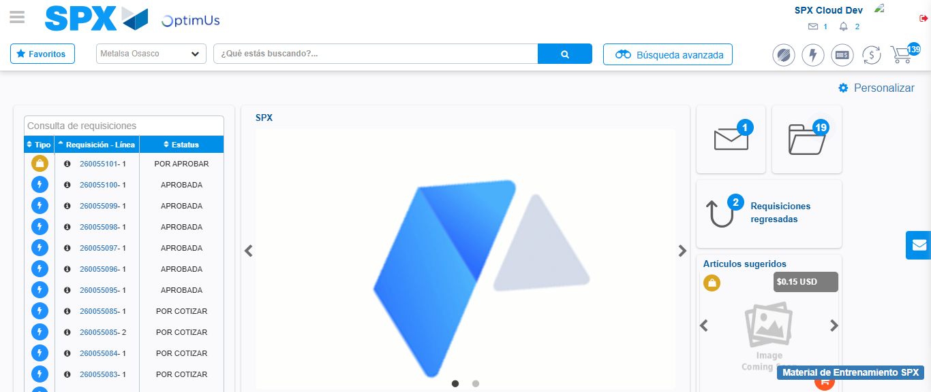Image file-name: QC_Testing-tc002_SPX_Dev5_Crear_Requisicion_Spot_Con_FAD_Tipo_Cobro_CC-1790170058611

Step 9 - Log Out : Log Out SPX
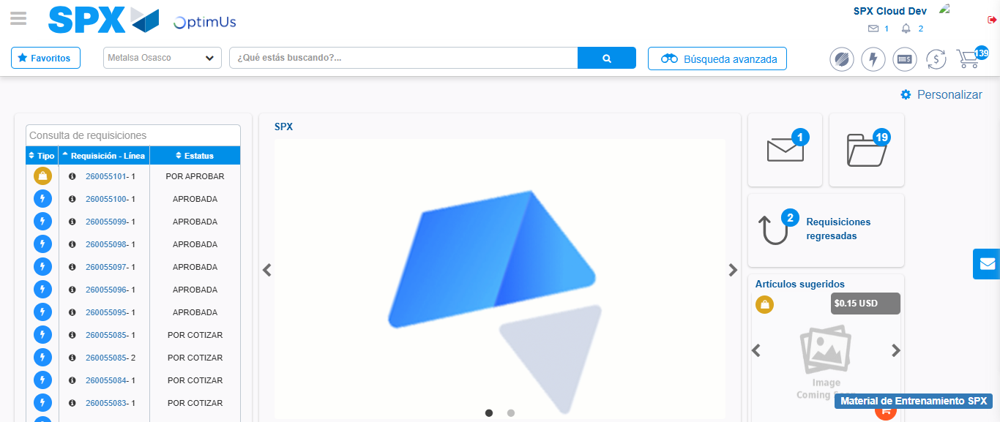Image file-name: QC_Testing-tc002_SPX_Dev5_Crear_Requisicion_Spot_Con_FAD_Tipo_Cobro_CC-1790170058968

